Areas of Stress or Pain: please indicate on the figure below areas we need to focus on.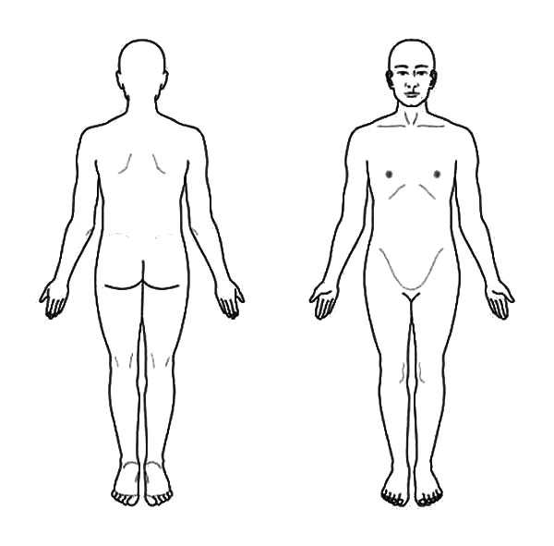
Rate your Stress or Pain: with “0” being “No Pain”, “5” being “Moderate Pain”, and “10” being “Severe Pain.”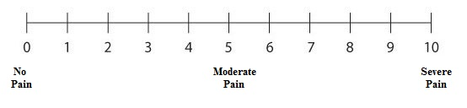
Desired Massage Pressure: with “0” being “Light”, “5” being “Medium”, and “10” being“Deep”.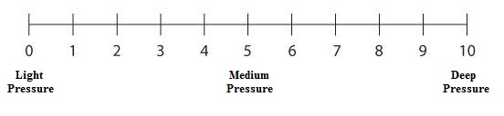
Areas to Avoid: please indicate whether you are comfortable having the following areas receiving therapeutic massage. “Y” indicating to NOT avoid, “N” indicating to please avoid.
Scalp:_Y_/_N_ Gluteals: _Y_/_N_ Abdominals: _Y_/_N_
Face: _Y_/_N_ Knees: _Y_/_N_ Other:________________________
Pectorals: _Y_/_N_ Feet: _Y_/_N_
SOAP Notes: for your therapist’s use only.
______________________________________________________________________________
S – Subjective Information
Focus for Today: _______________________________________________________________
______________________________________________________________________________
Symptoms: Location/Intensity/Frequency/Duration: ____________________________________
______________________________________________________________________________
Activities of Daily Living: Aggravating/Relieving: ____________________________________
______________________________________________________________________________
______________________________________________________________________________
O – Objective Information
Findings: Visual/Palpable/Test Results: _____________________________________________
______________________________________________________________________________
Modalities Used: Applications/Locations: ____________________________________________
____________________________________________________________________________________________________________________________________________________________
______________________________________________________________________________
A - Assessment
Goals: Long-Term/Short-Term: ____________________________________________________
______________________________________________________________________________
Response to Treatment: Functional/Verbalized: _______________________________________
______________________________________________________________________________
______________________________________________________________________________
P - Plan
Future Treatment Recommendations: _______________________________________________
______________________________________________________________________________
Self Care Recommendations: ______________________________________________________
______________________________________________________________________________
SOAP Notes: for your therapist’s use only.
______________________________________________________________________________
S – Subjective Information
Focus for Today: _______________________________________________________________
______________________________________________________________________________
Symptoms: Location/Intensity/Frequency/Duration: ____________________________________
______________________________________________________________________________
Activities of Daily Living: Aggravating/Relieving: ____________________________________
______________________________________________________________________________
______________________________________________________________________________
O – Objective Information
Findings: Visual/Palpable/Test Results: _____________________________________________
______________________________________________________________________________
Modalities Used: Applications/Locations: ____________________________________________
____________________________________________________________________________________________________________________________________________________________
______________________________________________________________________________
A - Assessment
Goals: Long-Term/Short-Term: ____________________________________________________
______________________________________________________________________________
Response to Treatment: Functional/Verbalized: _______________________________________
______________________________________________________________________________
______________________________________________________________________________
P - Plan
Future Treatment Recommendations: _______________________________________________
______________________________________________________________________________
Self Care Recommendations: ______________________________________________________
______________________________________________________________________________
SOAP Notes: for your therapist’s use only.
______________________________________________________________________________
S – Subjective Information
Focus for Today: _______________________________________________________________
______________________________________________________________________________
Symptoms: Location/Intensity/Frequency/Duration: ____________________________________
______________________________________________________________________________
Activities of Daily Living: Aggravating/Relieving: ____________________________________
______________________________________________________________________________
______________________________________________________________________________
O – Objective Information
Findings: Visual/Palpable/Test Results: _____________________________________________
______________________________________________________________________________
Modalities Used: Applications/Locations: ____________________________________________
____________________________________________________________________________________________________________________________________________________________
______________________________________________________________________________
A - Assessment
Goals: Long-Term/Short-Term: ____________________________________________________
______________________________________________________________________________
Response to Treatment: Functional/Verbalized: _______________________________________
______________________________________________________________________________
______________________________________________________________________________
P - Plan
Future Treatment Recommendations: _______________________________________________
______________________________________________________________________________
Self Care Recommendations: ______________________________________________________
______________________________________________________________________________
SOAP Notes: for your therapist’s use only.
______________________________________________________________________________
S – Subjective Information
Focus for Today: _______________________________________________________________
______________________________________________________________________________
Symptoms: Location/Intensity/Frequency/Duration: ____________________________________
______________________________________________________________________________
Activities of Daily Living: Aggravating/Relieving: ____________________________________
______________________________________________________________________________
______________________________________________________________________________
O – Objective Information
Findings: Visual/Palpable/Test Results: _____________________________________________
______________________________________________________________________________
Modalities Used: Applications/Locations: ____________________________________________
____________________________________________________________________________________________________________________________________________________________
______________________________________________________________________________
A - Assessment
Goals: Long-Term/Short-Term: ____________________________________________________
______________________________________________________________________________
Response to Treatment: Functional/Verbalized: _______________________________________
______________________________________________________________________________
______________________________________________________________________________
P - Plan
Future Treatment Recommendations: _______________________________________________
______________________________________________________________________________
Self Care Recommendations: ______________________________________________________
______________________________________________________________________________
SOAP Notes: for your therapist’s use only.
______________________________________________________________________________
S – Subjective Information
Focus for Today: _______________________________________________________________
______________________________________________________________________________
Symptoms: Location/Intensity/Frequency/Duration: ____________________________________
______________________________________________________________________________
Activities of Daily Living: Aggravating/Relieving: ____________________________________
______________________________________________________________________________
______________________________________________________________________________
O – Objective Information
Findings: Visual/Palpable/Test Results: _____________________________________________
______________________________________________________________________________
Modalities Used: Applications/Locations: ____________________________________________
____________________________________________________________________________________________________________________________________________________________
______________________________________________________________________________
A - Assessment
Goals: Long-Term/Short-Term: ____________________________________________________
______________________________________________________________________________
Response to Treatment: Functional/Verbalized: _______________________________________
______________________________________________________________________________
______________________________________________________________________________
P - Plan
Future Treatment Recommendations: _______________________________________________
______________________________________________________________________________
Self Care Recommendations: ______________________________________________________
______________________________________________________________________________
SOAP Notes: for your therapist’s use only.
______________________________________________________________________________
S – Subjective Information
Focus for Today: _______________________________________________________________
______________________________________________________________________________
Symptoms: Location/Intensity/Frequency/Duration: ____________________________________
______________________________________________________________________________
Activities of Daily Living: Aggravating/Relieving: ____________________________________
______________________________________________________________________________
______________________________________________________________________________
O – Objective Information
Findings: Visual/Palpable/Test Results: _____________________________________________
______________________________________________________________________________
Modalities Used: Applications/Locations: ____________________________________________
____________________________________________________________________________________________________________________________________________________________
______________________________________________________________________________
A - Assessment
Goals: Long-Term/Short-Term: ____________________________________________________
______________________________________________________________________________
Response to Treatment: Functional/Verbalized: _______________________________________
______________________________________________________________________________
______________________________________________________________________________
P - Plan
Future Treatment Recommendations: _______________________________________________
______________________________________________________________________________
Self Care Recommendations: ______________________________________________________
______________________________________________________________________________
SOAP Notes: for your therapist’s use only.
______________________________________________________________________________
S – Subjective Information
Focus for Today: _______________________________________________________________
______________________________________________________________________________
Symptoms: Location/Intensity/Frequency/Duration: ____________________________________
______________________________________________________________________________
Activities of Daily Living: Aggravating/Relieving: ____________________________________
______________________________________________________________________________
______________________________________________________________________________
O – Objective Information
Findings: Visual/Palpable/Test Results: _____________________________________________
______________________________________________________________________________
Modalities Used: Applications/Locations: ____________________________________________
____________________________________________________________________________________________________________________________________________________________
______________________________________________________________________________
A - Assessment
Goals: Long-Term/Short-Term: ____________________________________________________
______________________________________________________________________________
Response to Treatment: Functional/Verbalized: _______________________________________
______________________________________________________________________________
______________________________________________________________________________
P - Plan
Future Treatment Recommendations: _______________________________________________
______________________________________________________________________________
Self Care Recommendations: ______________________________________________________
______________________________________________________________________________
SOAP Notes: for your therapist’s use only.
______________________________________________________________________________
S – Subjective Information
Focus for Today: _______________________________________________________________
______________________________________________________________________________
Symptoms: Location/Intensity/Frequency/Duration: ____________________________________
______________________________________________________________________________
Activities of Daily Living: Aggravating/Relieving: ____________________________________
______________________________________________________________________________
______________________________________________________________________________
O – Objective Information
Findings: Visual/Palpable/Test Results: _____________________________________________
______________________________________________________________________________
Modalities Used: Applications/Locations: ____________________________________________
____________________________________________________________________________________________________________________________________________________________
______________________________________________________________________________
A - Assessment
Goals: Long-Term/Short-Term: ____________________________________________________
______________________________________________________________________________
Response to Treatment: Functional/Verbalized: _______________________________________
______________________________________________________________________________
______________________________________________________________________________
P - Plan
Future Treatment Recommendations: _______________________________________________
______________________________________________________________________________
Self Care Recommendations: ______________________________________________________
______________________________________________________________________________

